New project

* .NET Standard 4.5
* Dynamo 2.0

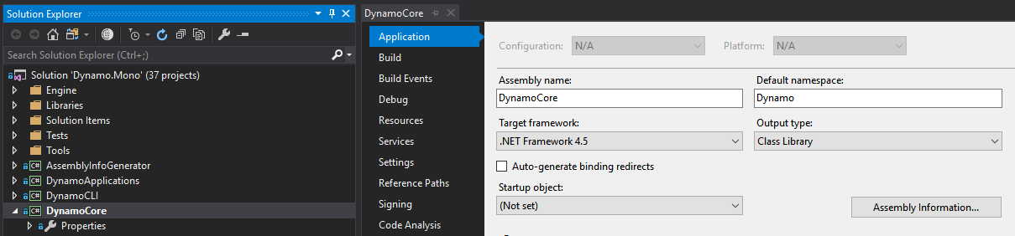

References

* DynamoCoreWpf - C:\Program Files\Dynamo\Dynamo Core\2\DynamoCoreWpf.dll
* PresentationFramework
* PresentationCore
* WindowsBase
* System.Windows

Observations

* Open Dynamo.All not Dynamo.Mono
  + Dynamo all includes the UI
* DynamoModel vs DynamoViewModel
  + Each have a location where our extension can be loaded
  + DynamoModel – Search for “Load()”
  + ViewExtensionLoader – search for “LoadDirectory()”
  + We can test our extension loading inside of the Dynamo solution at the code in those two locations

Process:

1. DynamoCoreWpf
   1. Copy local = false
2. Implement IViewExtension:
   1. Implementing interfaces
3. Give Unique Id
4. Give Name
5. Implement Loaded method
   1. Review methods that exist
   2. Save Window as casted DynamoView
      1. Reference Presentation Framework
6. Message.ShowDialog on View Loaded
   1. Wire into an event
   2. Event driven architecture
7. Set startup project for debug
   1. "C:\Program Files\Dynamo\Dynamo Core\2\DynamoSandbox.exe"
8. Still need to place xml and the built dll in the correct folder
   1. ViewExtensions - C:\Program Files\Dynamo\Dynamo Core\2\viewExtensions
   2. Extensions – C:\Program Files\Dynamo\Dynamo Core\2\extensions
   3. Packages folder
9. Setup project
   1. Debug by activating the DynamoSandbox.exe
   2. Build event to copy xml resources from Resource folder to Deploy folder
10. Create bat files to do the “installation” of a dynamo extension